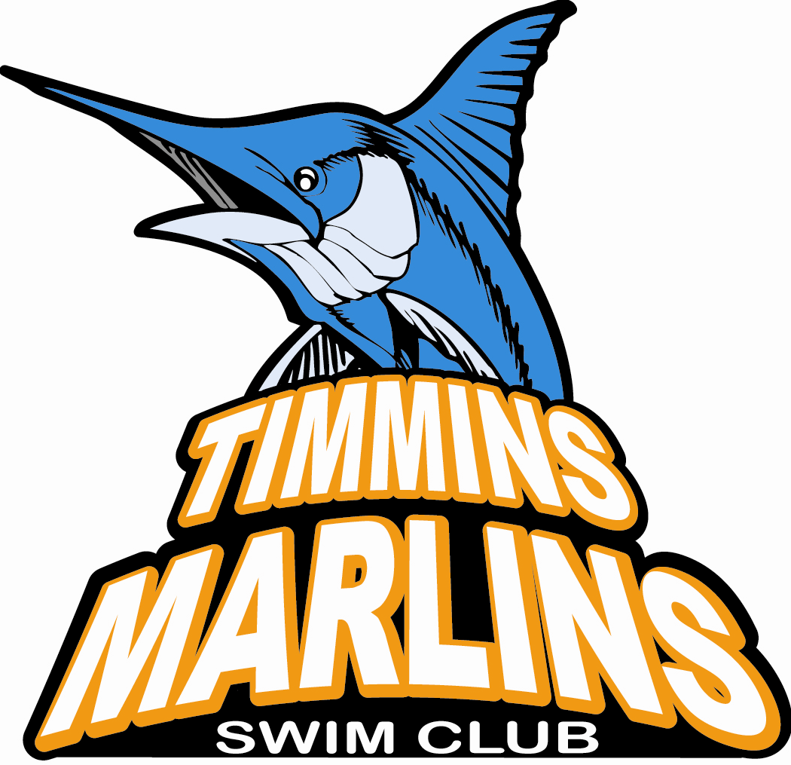

September 12, 2023

Dear SPONSOR,

The Timmins Marlins Swim Club is proudly celebrating 40 years of competitive swimming in our community. We are a volunteer-run, not for profit organization sanctioned through Swim Ontario and Swimming Natation Canada, our provincial and national governing bodies. The Marlins are dedicated to the sport of competitive swimming and our club philosophy emphasizes helping every swimmer “To be the best you can be” in the pool and in our community.

Each year our swimmers proudly represent Timmins at swim meets locally, across the province, the country and even internationally at times. Our swimmers are great role models for healthy active living.

This year we are raising money to help subsidize our swimmer’s training, meet and transportation costs. We are asking for sponsorship in the amount of $350 to sponsor a swimmer’s t-shirt.

Please confirm your willingness to sponsor MY SWIMMER’S NAME no later than October 8, 2023.

Thank you for your consideration and your support.

YOUR NAME

